Cloud

Q1)

Step1- first wo go in EC2

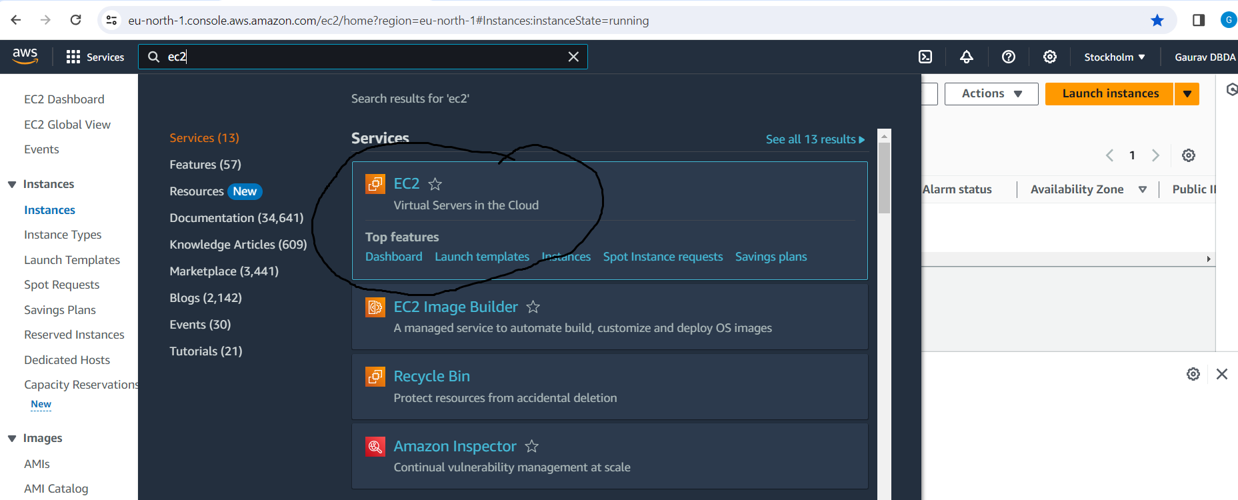

Step 2- Launch instance

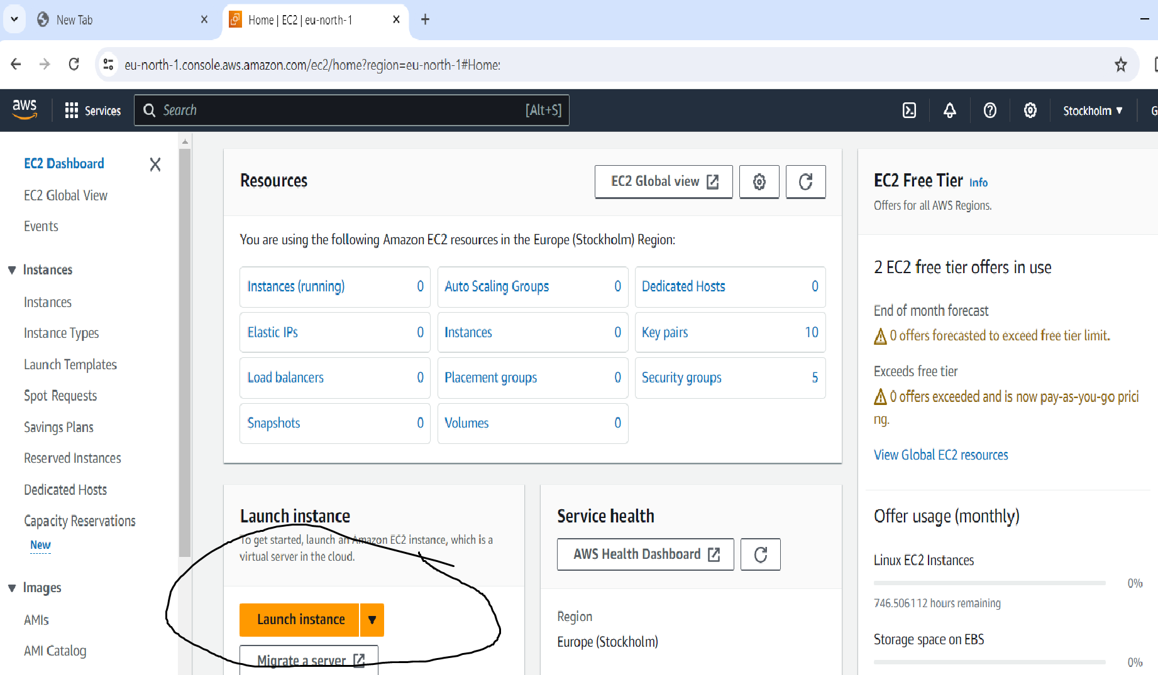

Step 3- create instance of name GauravDBDA

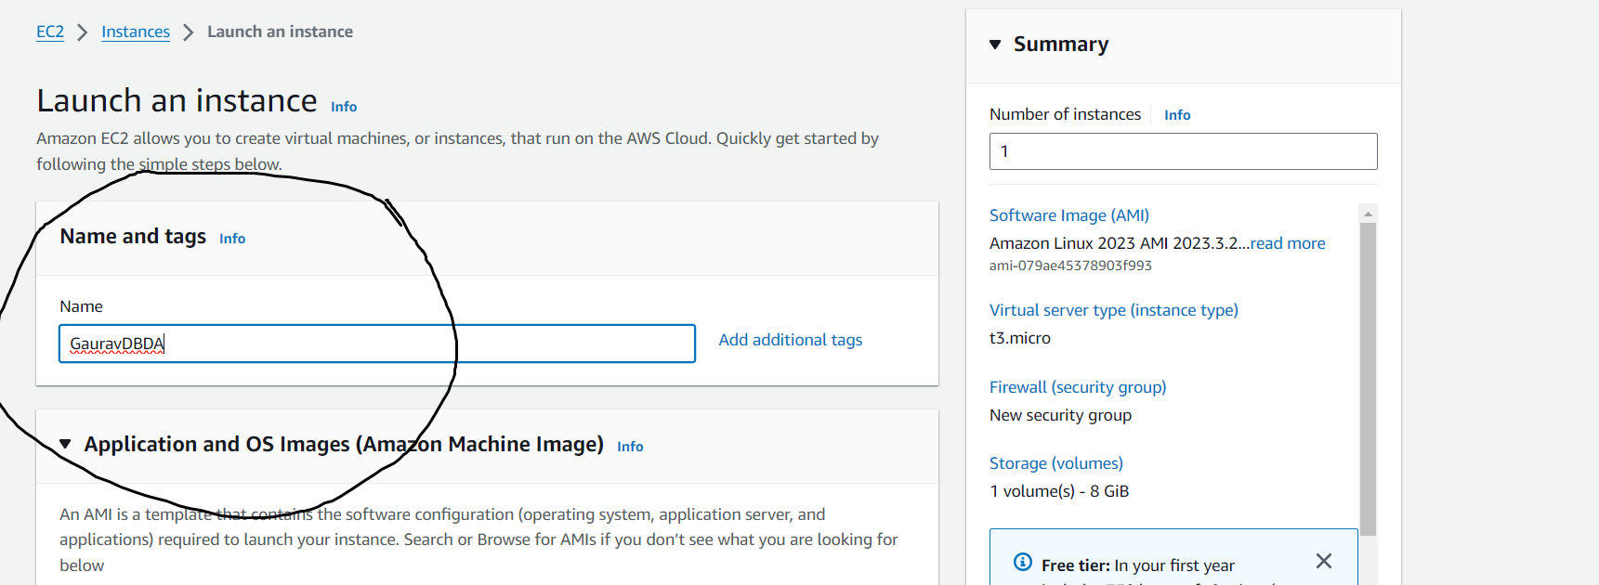

Step 4- Then create new key pair

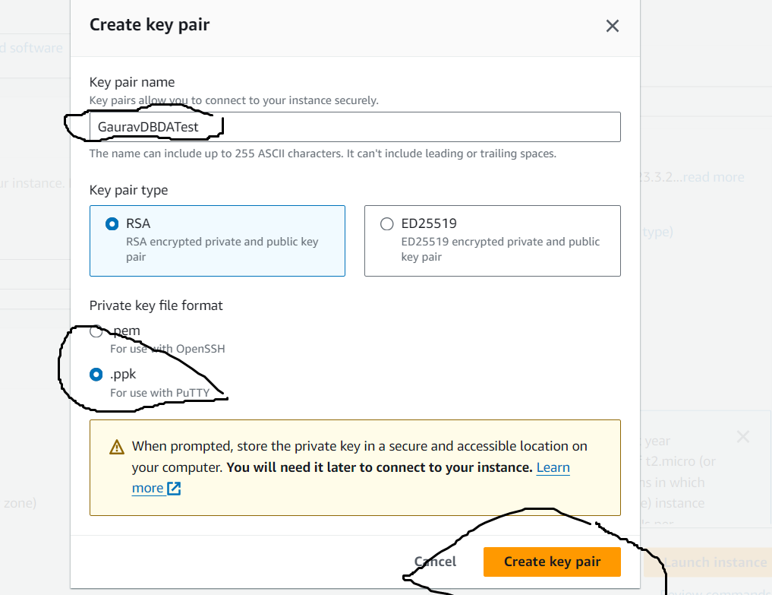

Step5 -

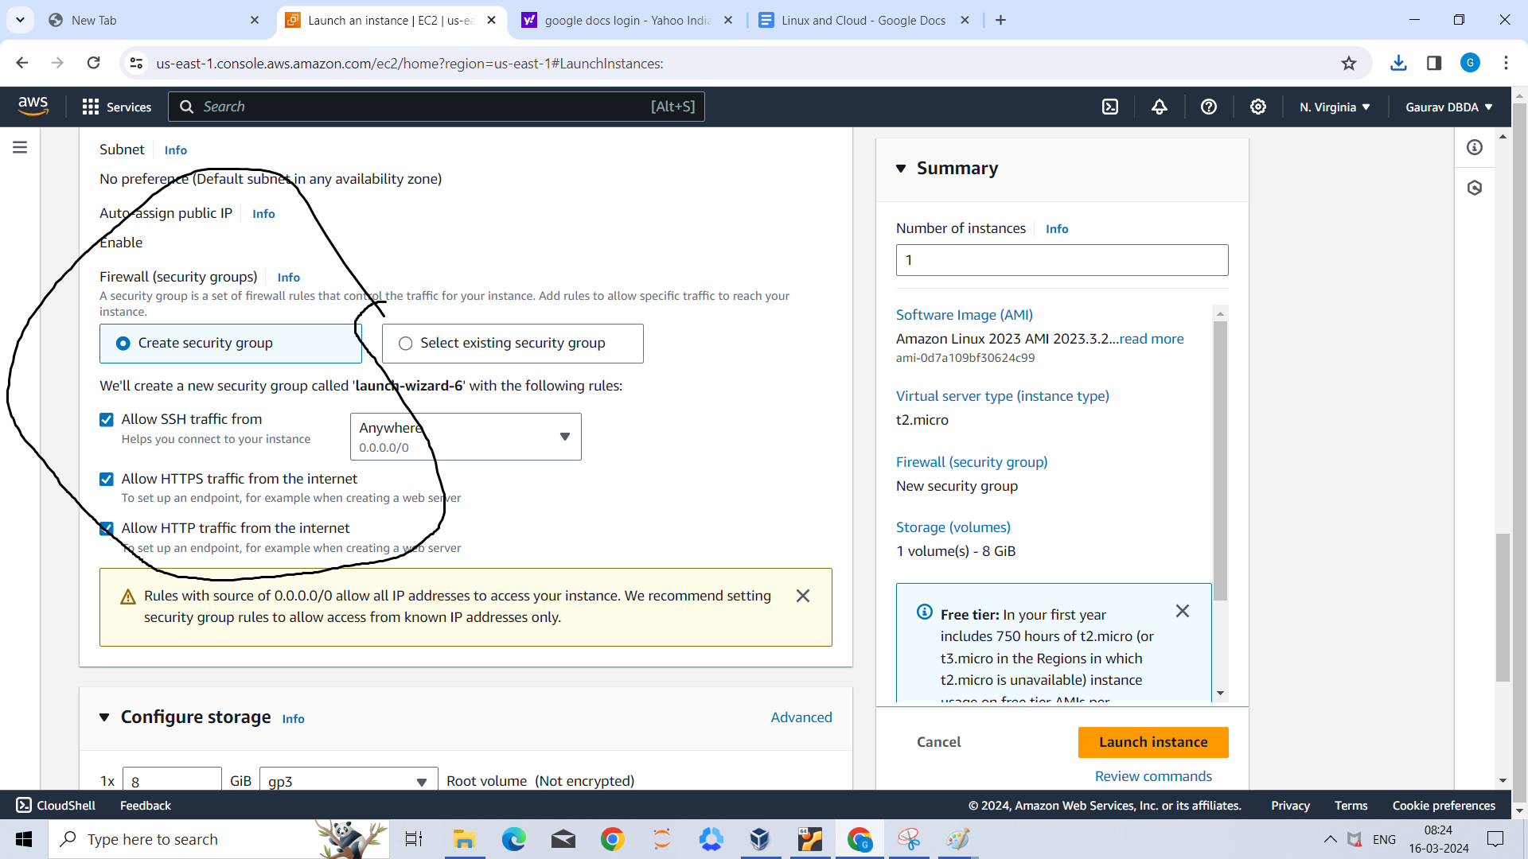

Step6 - Then Launch instance

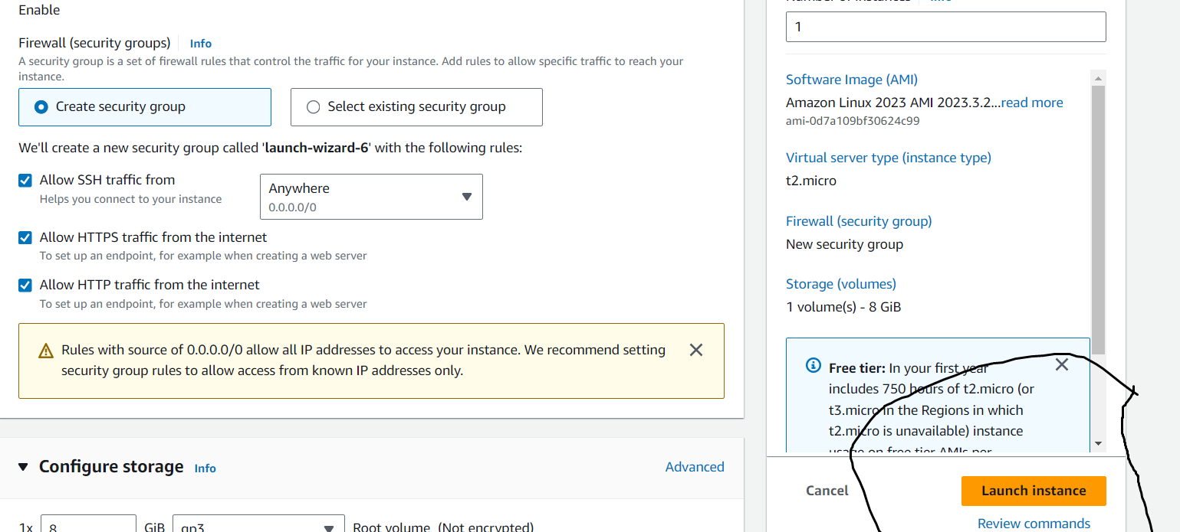

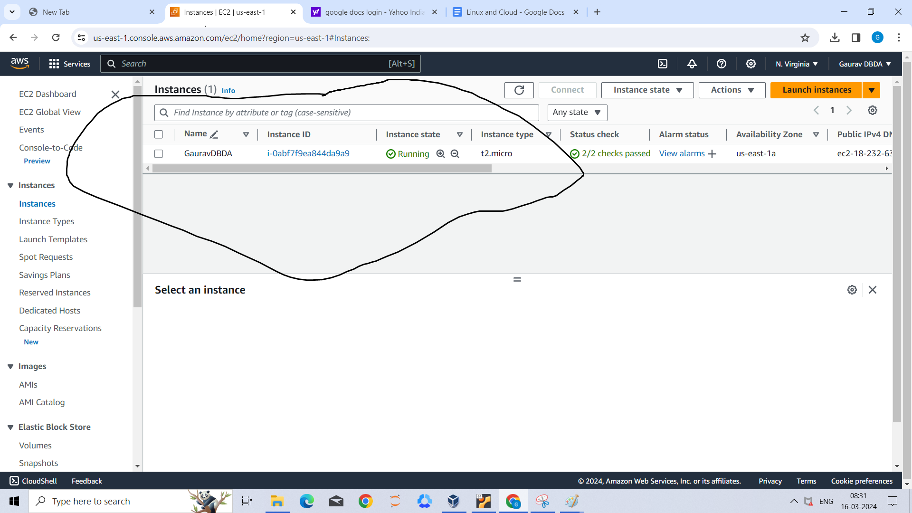

Step7 - Then I open putty and give public ip

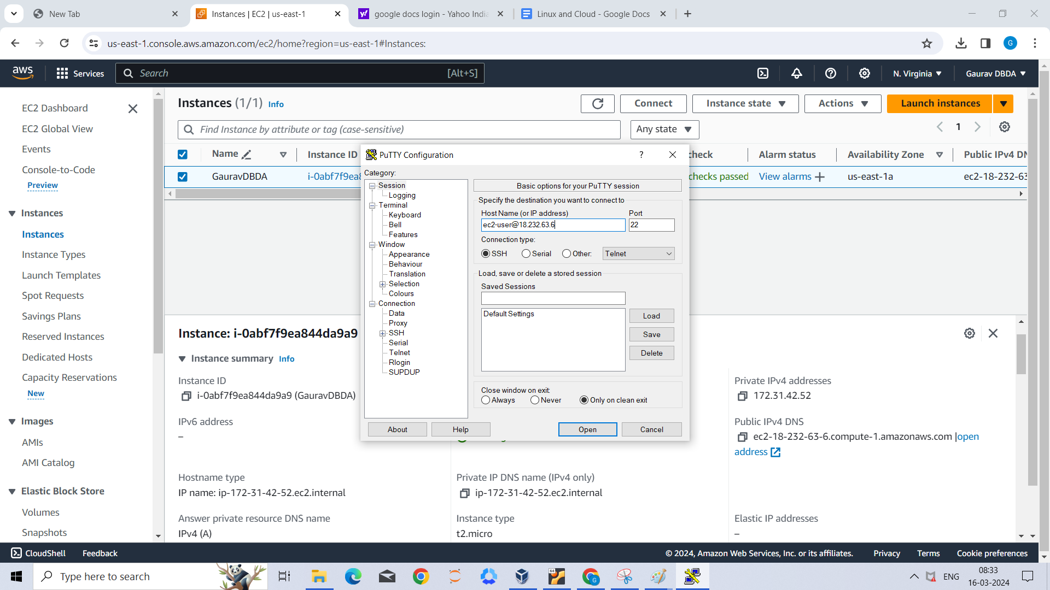

Step 8- Then go to SHH in that Auth and credential and add key pair

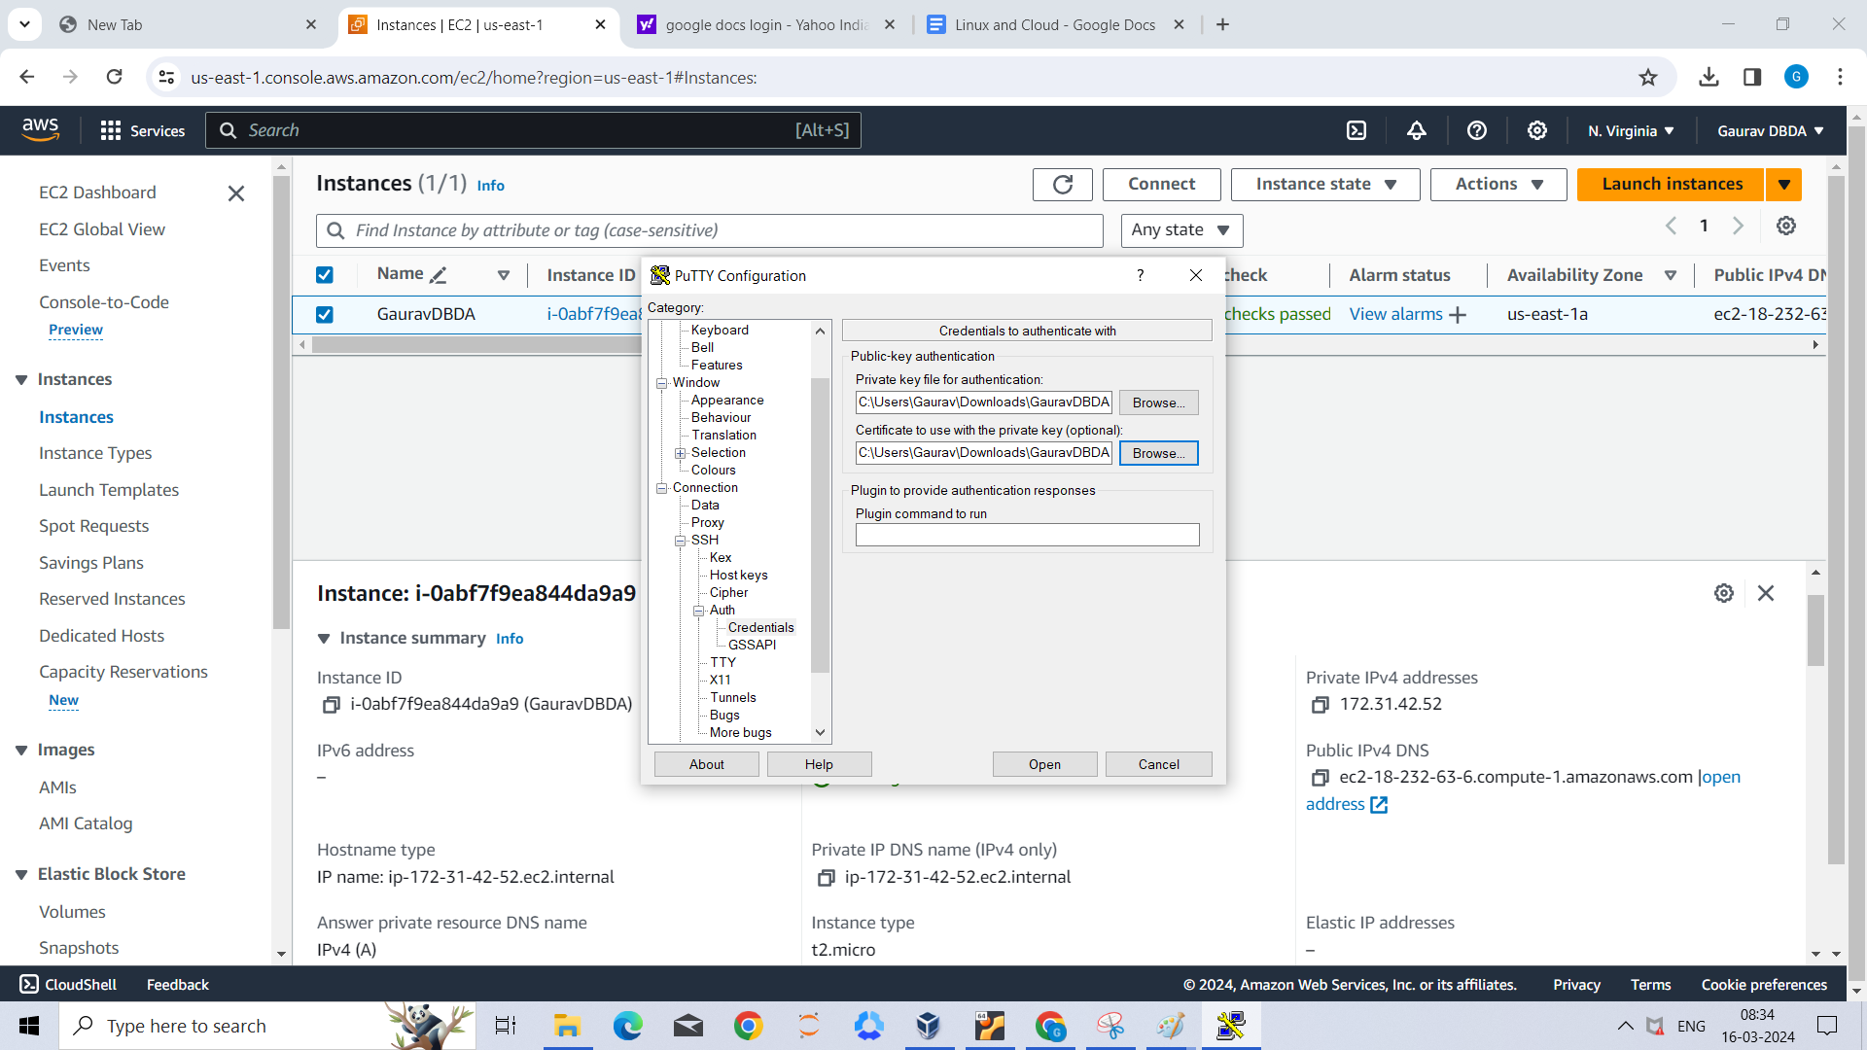

Step 9 - then click on ok

Step 10- it open

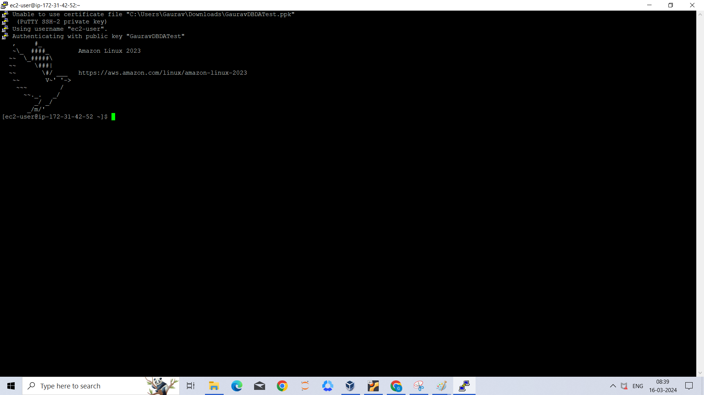

Step 11-

Sudo -i

yum update -y

yum install httpd -y

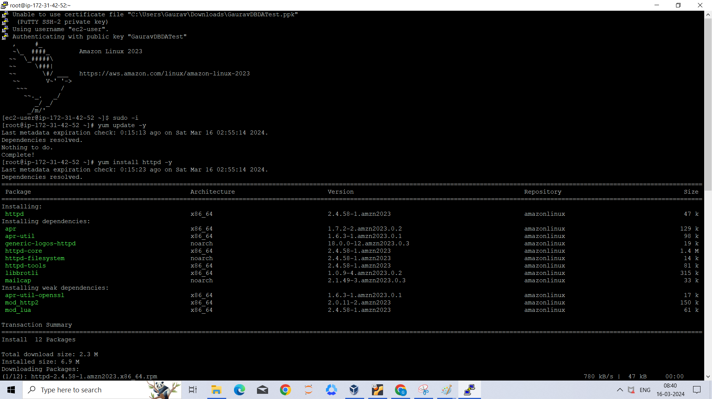

Step-12

Systemctl start httpd

Systemctl status httpd

Systemctl enable httpd

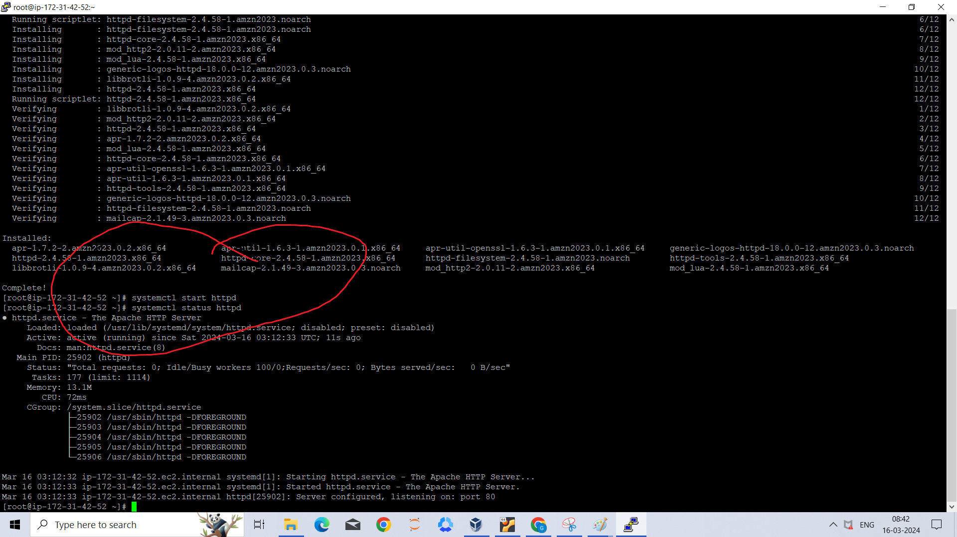

Step 14-then

Cd /var/www/html

ls

Nano index.html

Cat

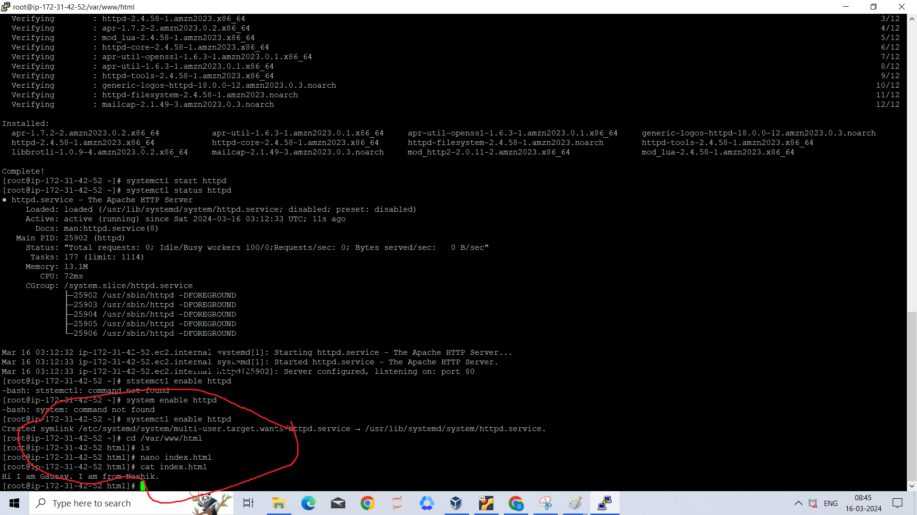

Step 15 -

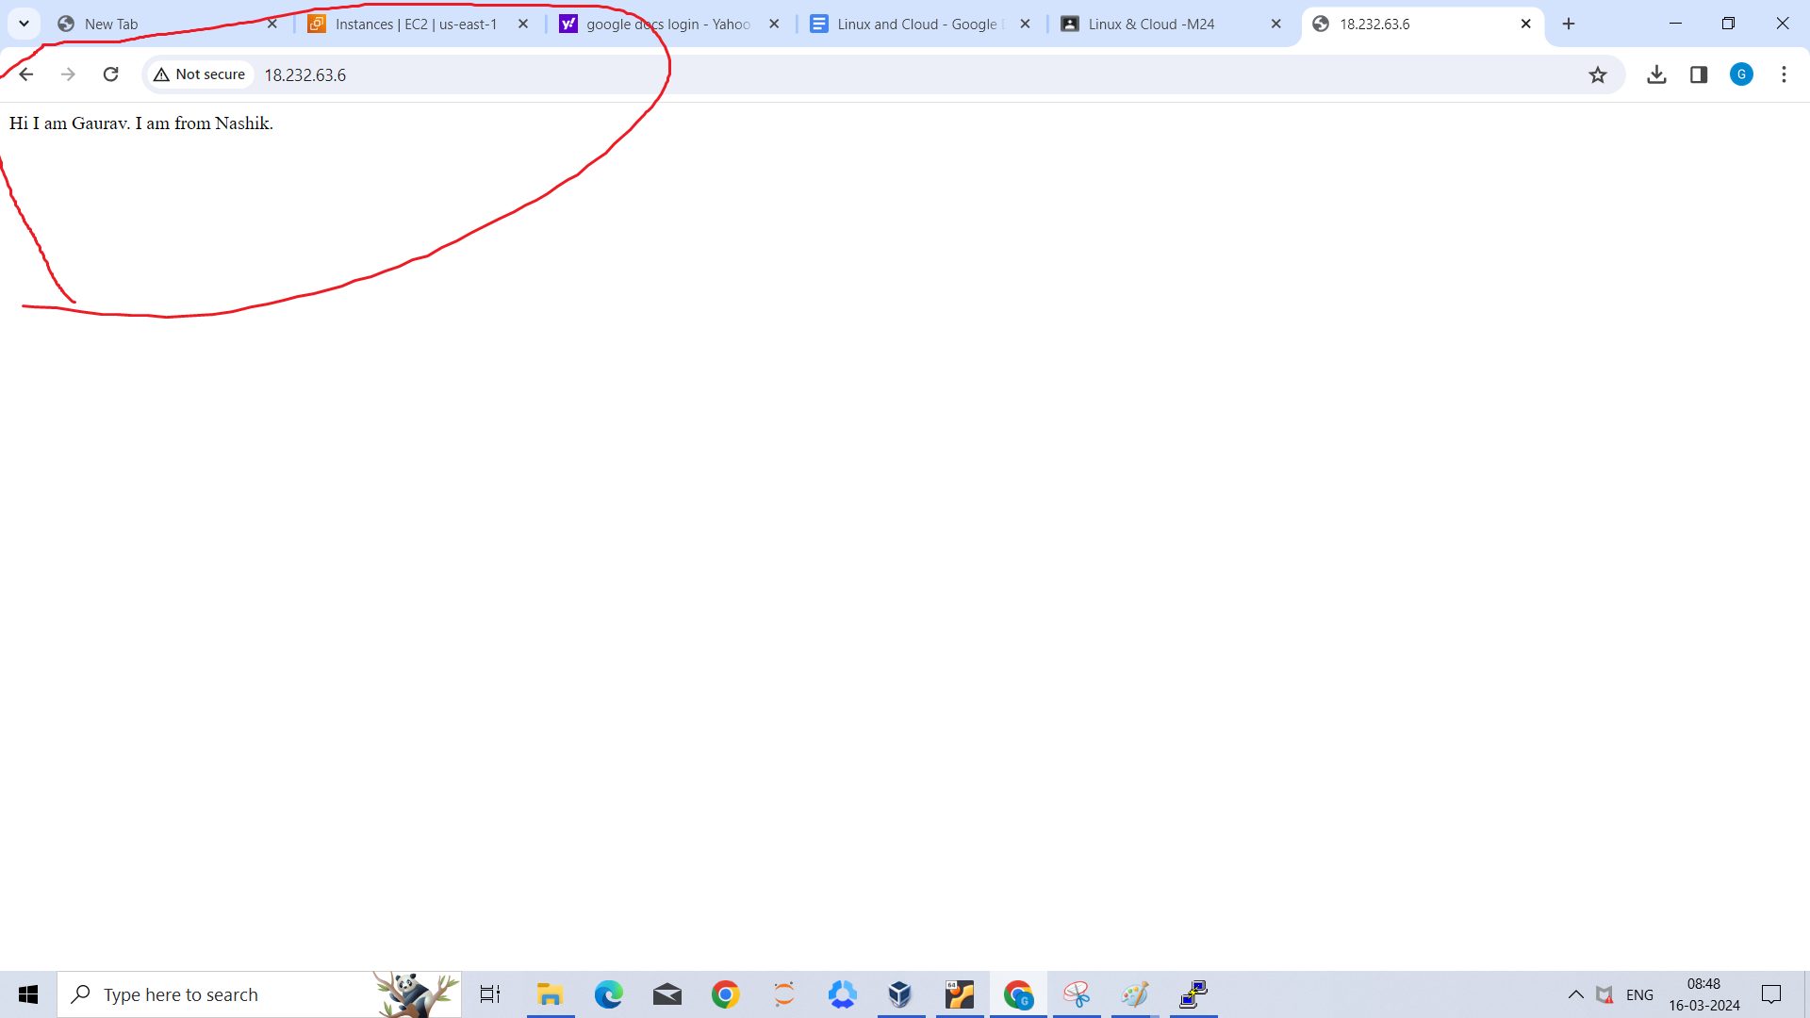

Step 16-

Done

Q2) s3

Step1 - go to s3

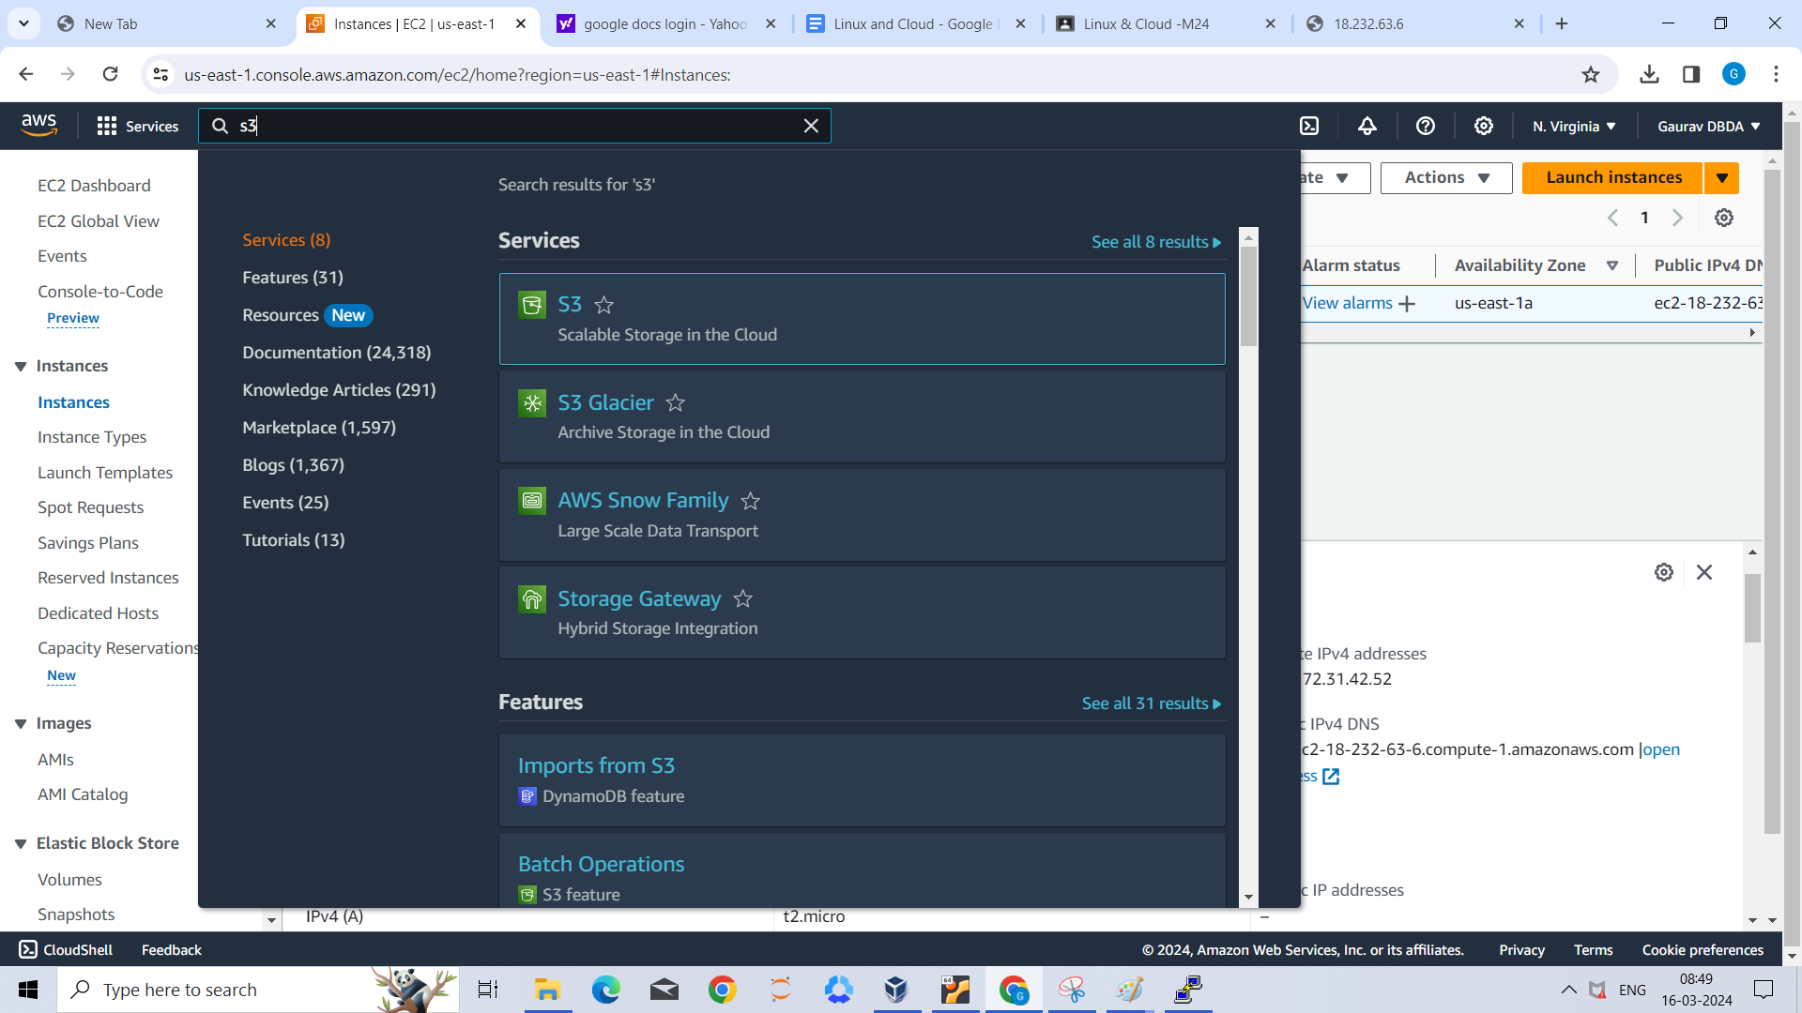

Step2-then create bucket

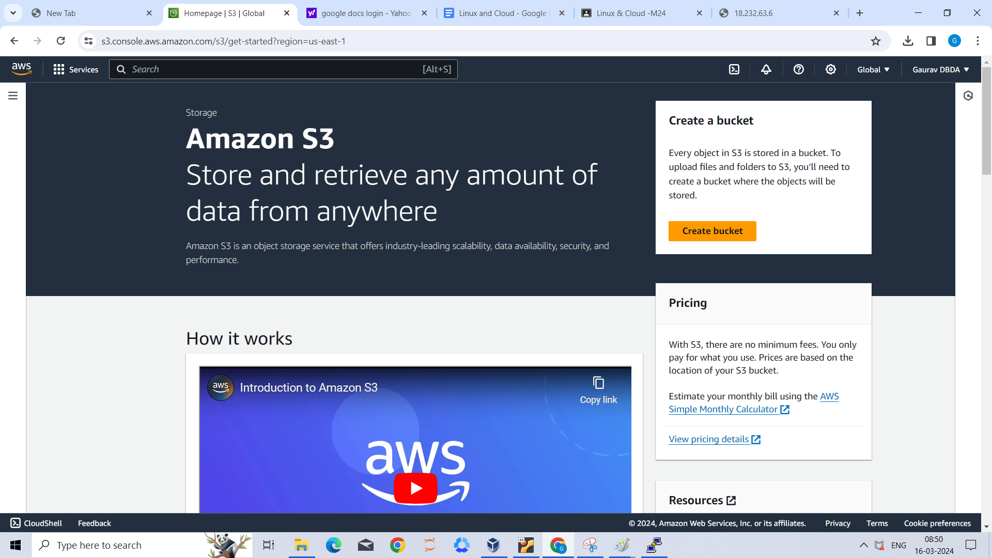

Step4- then give name ninjahk to bucket. It is ninja in image but i change after because ninja is not present.

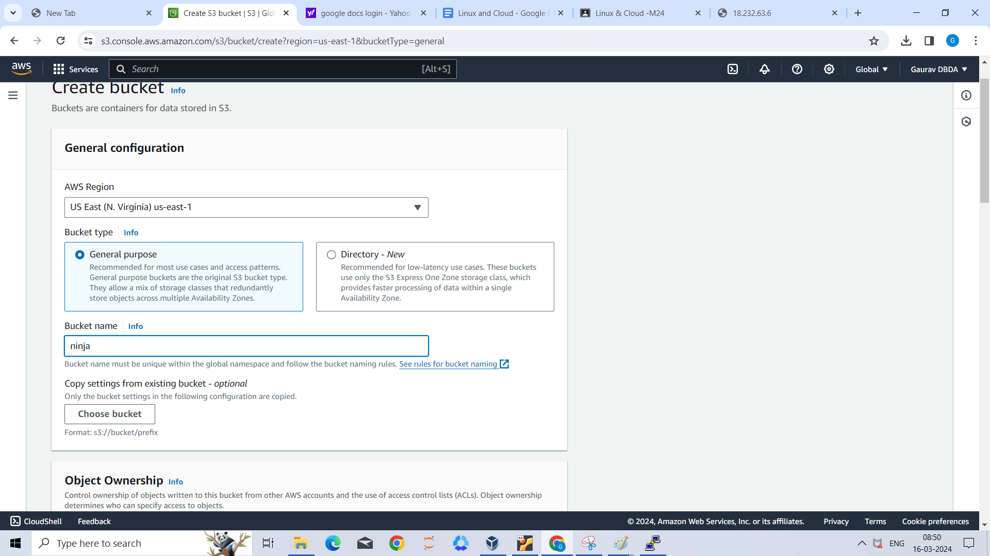

Step4- then uncheck all the boxes of block public axes

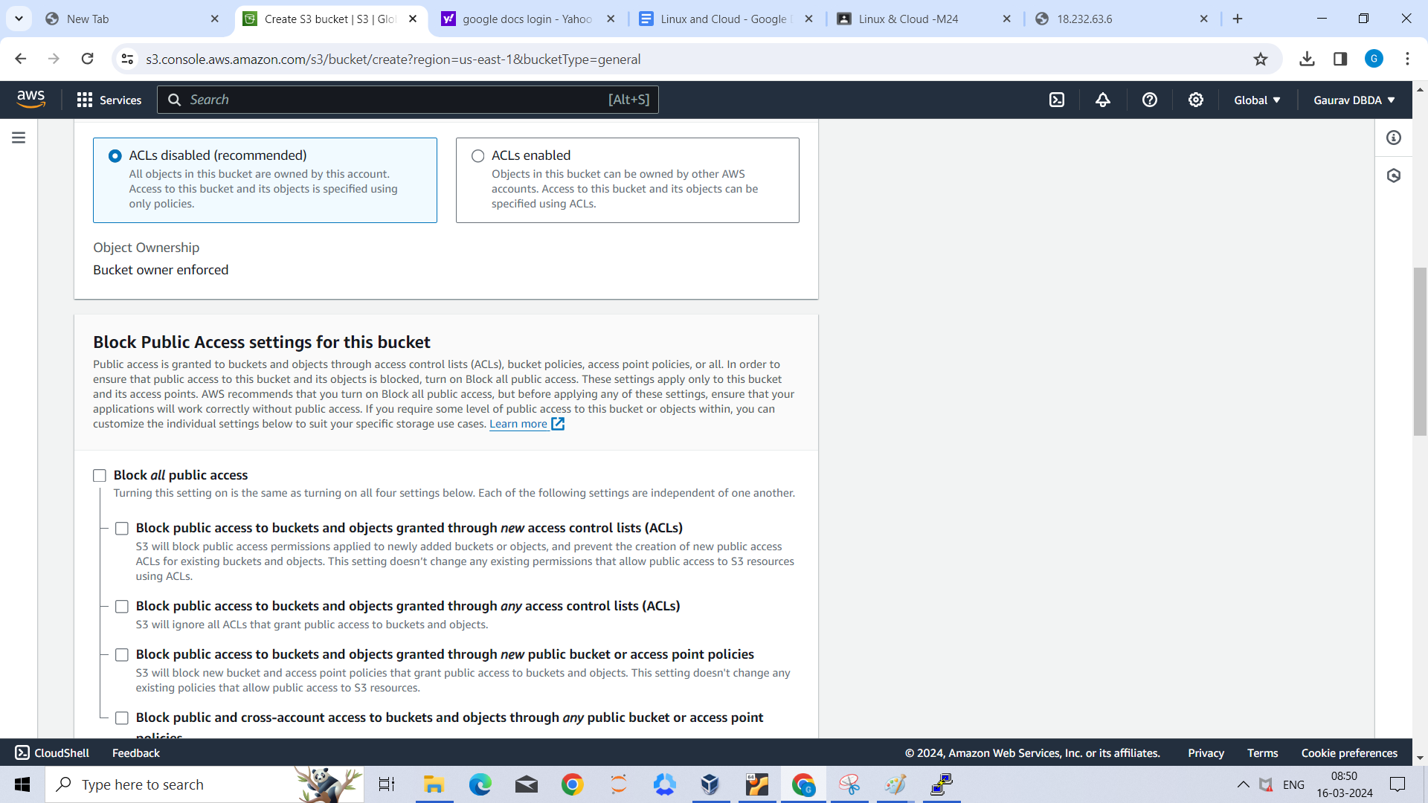

Step5-

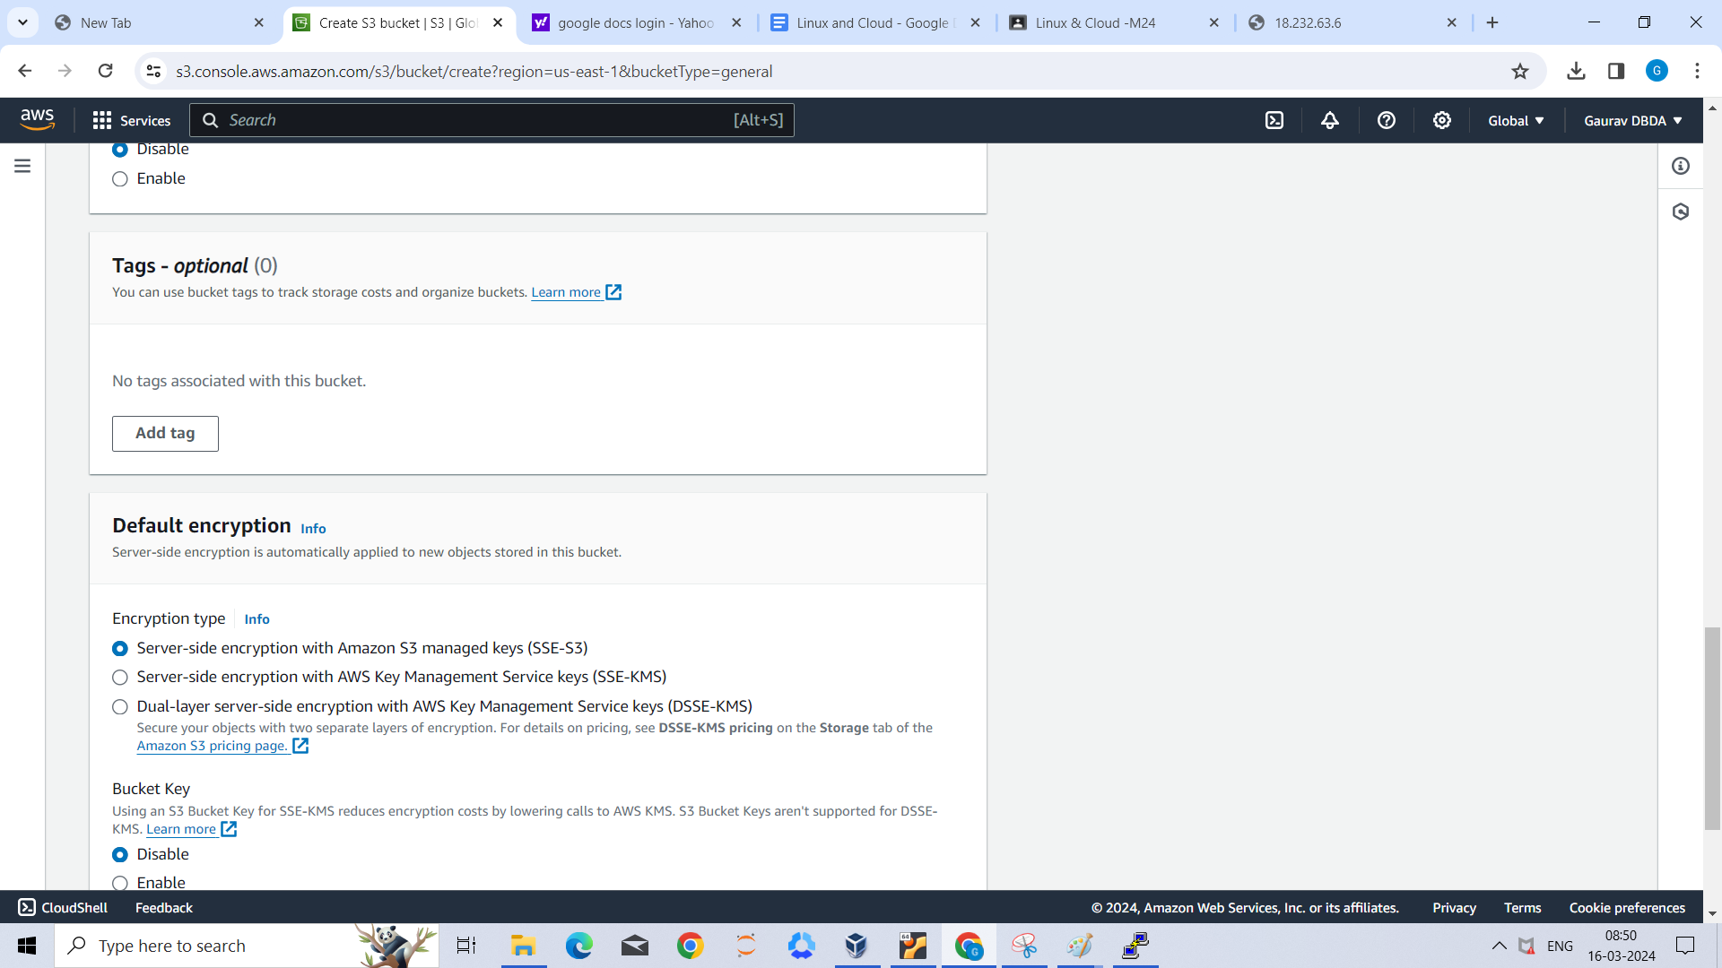

Step7 - then create bucket

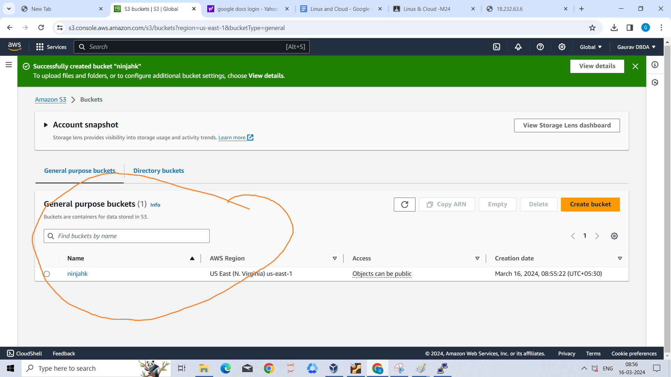

Step 7-Then upload some file in that and edit access to read

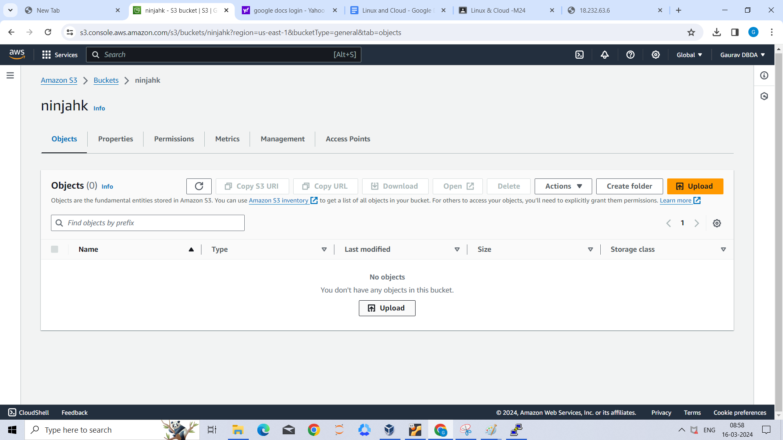

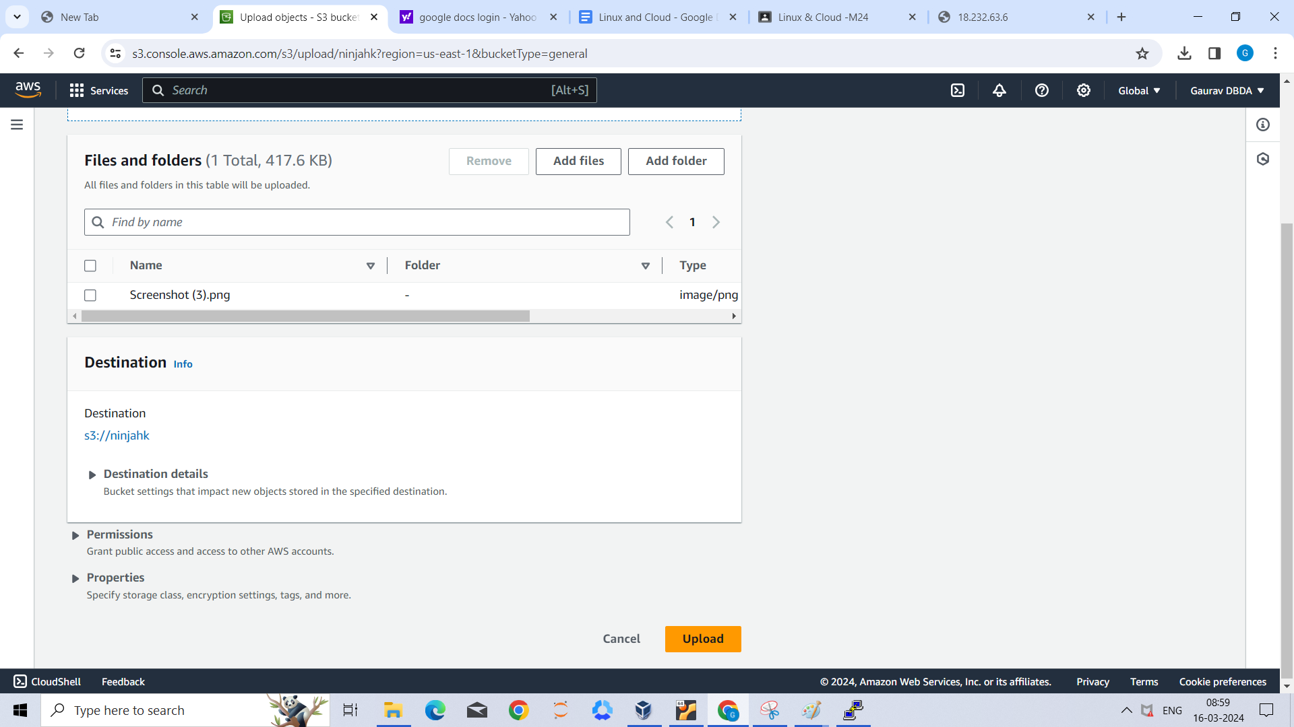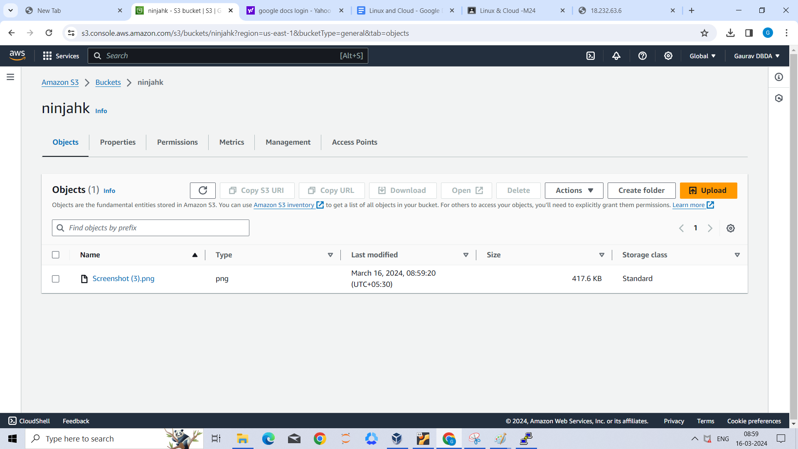

Step 8- Then edit Aceess

For that i click on image go to permissions

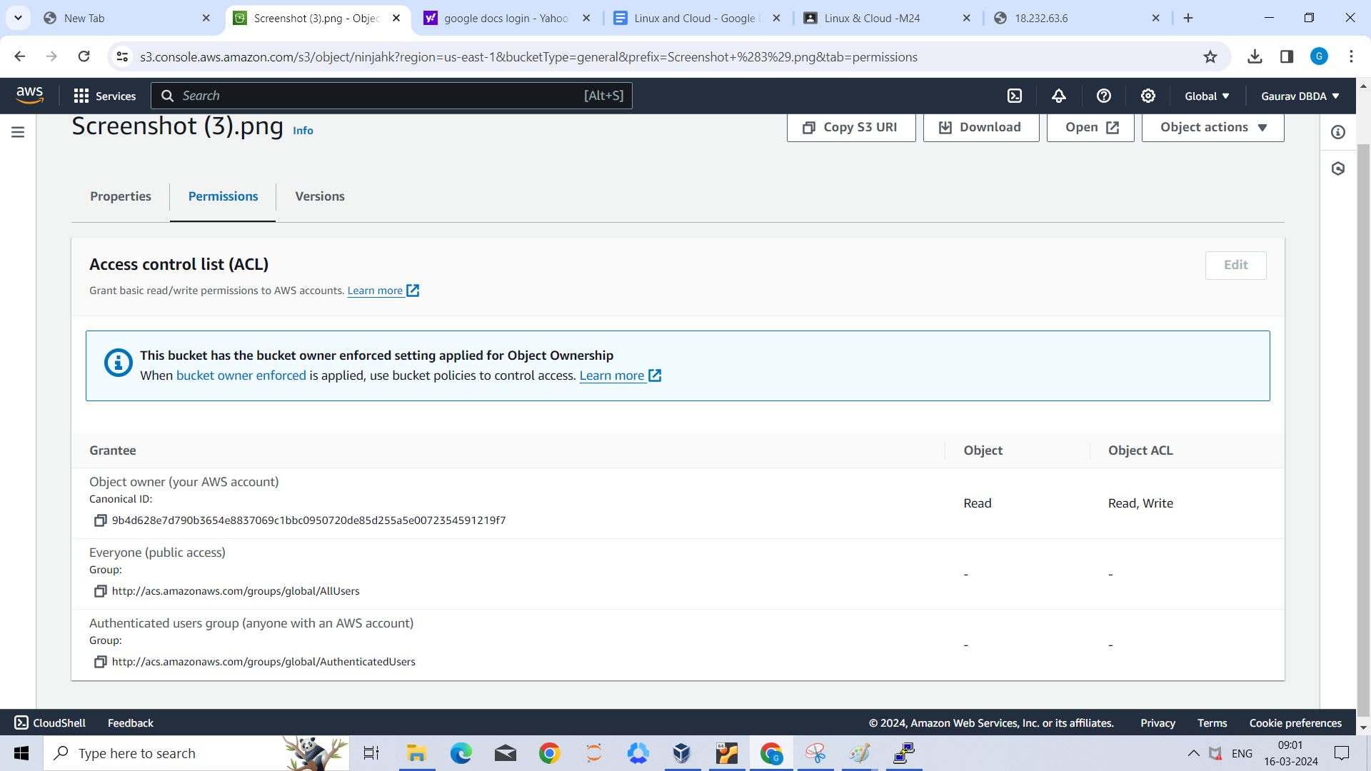

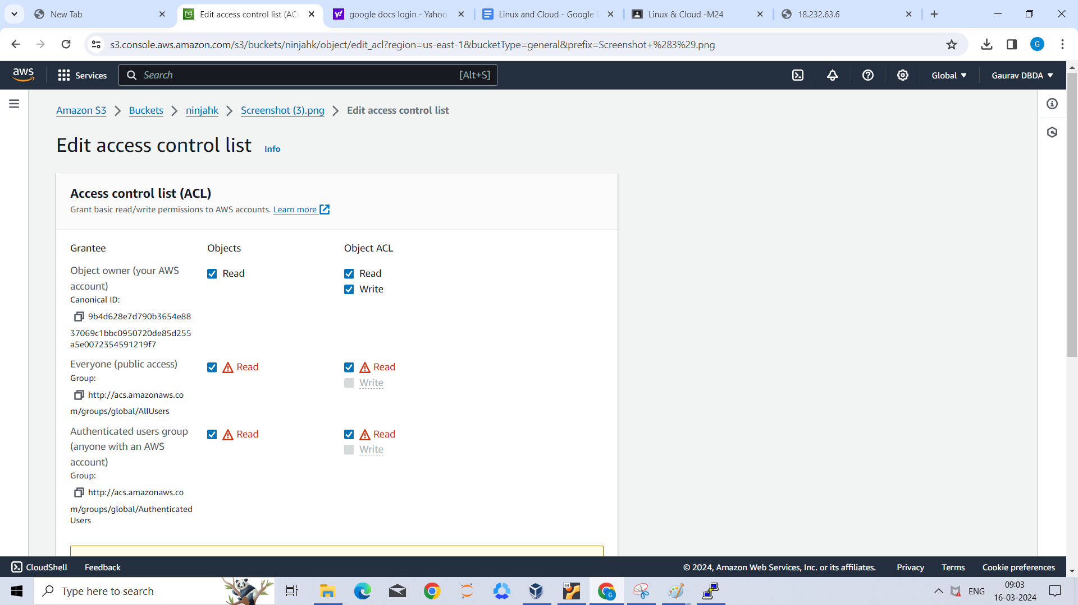

Stpe 10 - then i click on object url then it open image that i have uploaded.

Object url : https://ninjahk.s3.amazonaws.com/Screenshot+(3).png

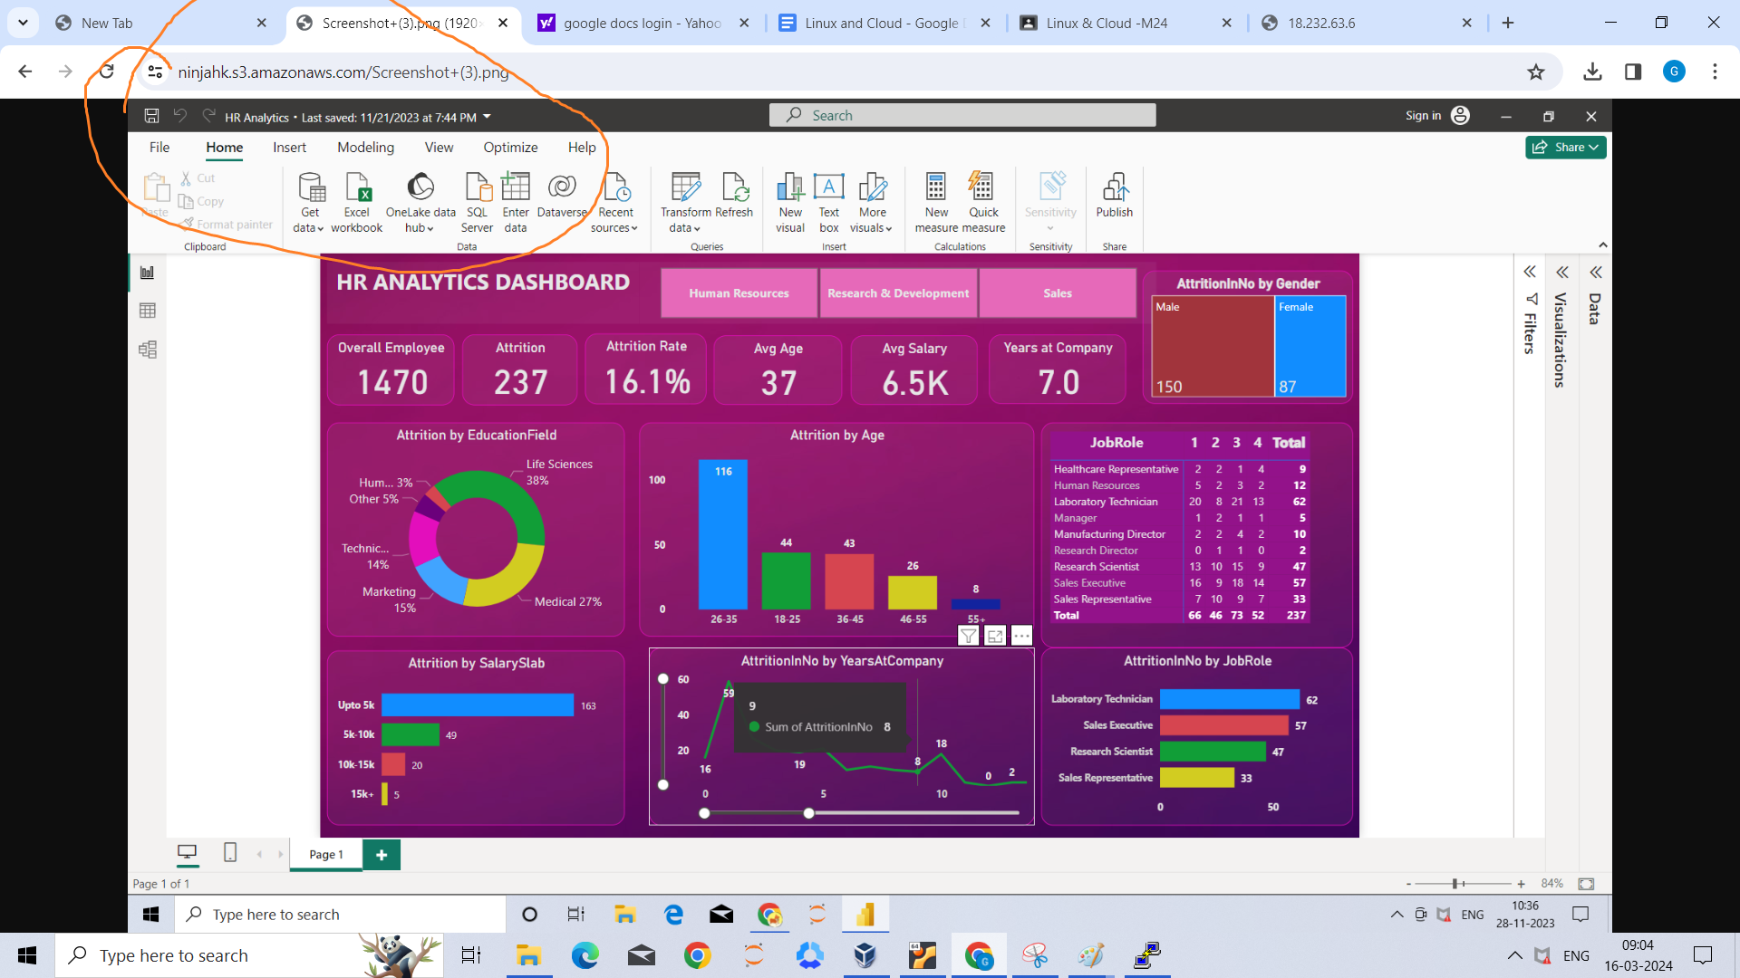

Linux

Q2)

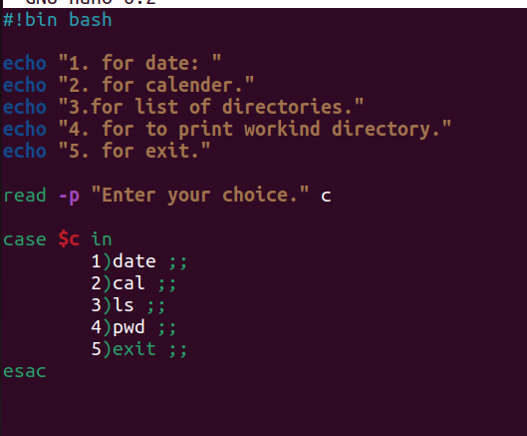

Output:

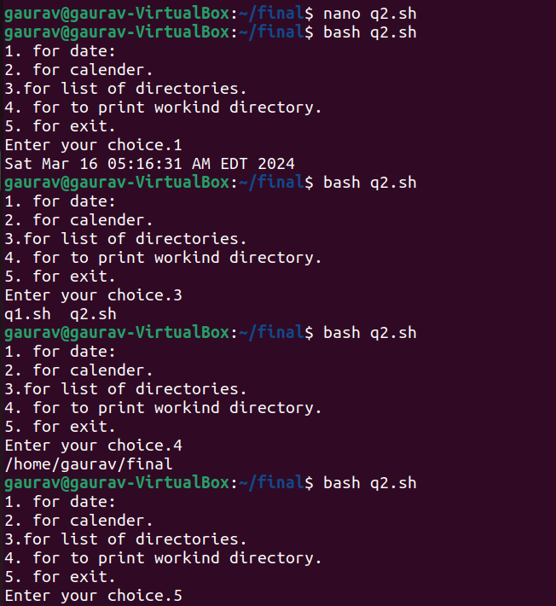

Q1)

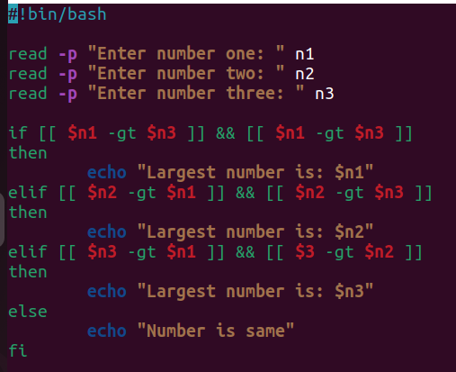

Output:

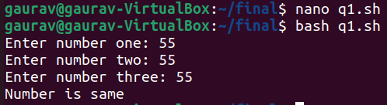

Q3)

